Individual Pathways
Activity 6.3
Investigating the atom further
- The following diagram shows a time sequence for the decay of a radioactive parent nucleus (sodium-24) into a stable daughter nucleus. The parent nucleus is coloured black. Estimate the half-life of sodium-24.
....................................................................................
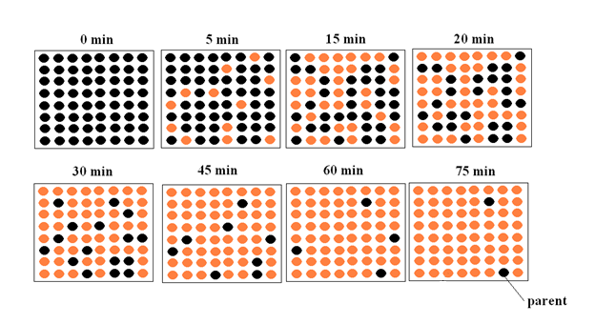

- The number of stable isotopes for elements with atomic numbers from 21 to 30 is recorded in the table below.
Atomic number | 21 | 22 | 23 | 24 | 25 | 26 | 27 | 28 | 29 | 30
Number of stable isotopes | 1 | 5 | 1 | 3 | 1 | 4 | 1 | 5 | 2 | 5

State one conclusion that can be made about isotope stability from this data.
..............................................................................................................................................................
..............................................................................................................................................................

- The following graph is a plot of neutron number versus proton number for stable isotopes.

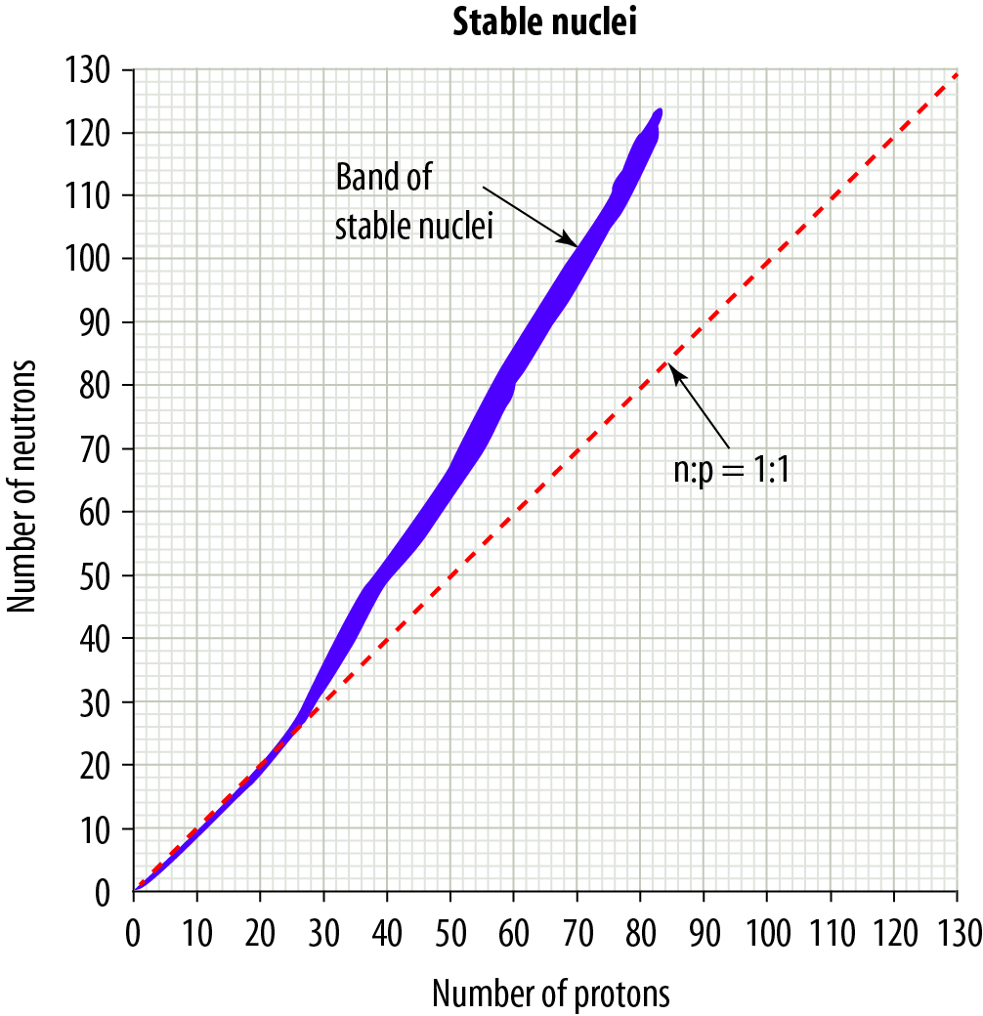

- A nucleus contains 10 protons. How many neutrons must be present to make this nucleus stable?
....................................................
- A nucleus contains 60 protons. How many neutrons must be present to make this nucleus stable?
....................................................
- As nuclei get heavier due to increasing numbers of protons and neutrons, how does the ratio of neutrons change to ensure isotope stability?
....................................................
- An element X has an isotope with a Z value of 50 and an A value of 50. Predict whether this isotope is stable or unstable.
....................................................

- The isotope carbon-14 has a half-life of 5730 years. A fossil was radiometrically dated by measuring the amount of C-14 left in the fossil. It was found that 6.25% of the C-14 remained.
How old is the fossil?
.......................................................................................................................................................

- In 1919, Ernest Rutherford became the first person to convert one element into another element. He fired an alpha particle (He-4) at a nitrogen-14 atom, and an oxygen-17 atom formed together with another sub-atomic particle that was released.

- Calculate the total number of protons and the total number of neutrons in an alpha particle and a nitrogen-14 atom.
.........................................................................................................................................
- Calculate the number of protons and neutrons in an oxygen-17 atom.
........................................................................................................................................
- Thus determine what sub-atomic particle was released.
.........................................................................................................................................

- Consider the following nuclear reaction.

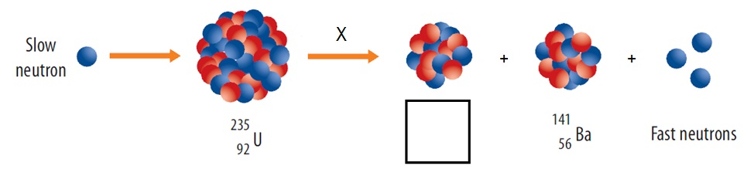
- Identify the nuclear process (X).
.......................................................
- One of the nuclear products is not labelled. Identify the isotope that has formed apart from barium-141.
..............................................................................................................................................................................................................................................................................................................

- Iodine-131 and iodine-123 are medical radioisotopes that are used to diagnose and treat cancers of the thyroid gland. Iodine-131 has a half-life of 8 days and iodine-123 has a half-life of 13 hours. The iodine radioisotopes travel through the bloodstream to the thyroid gland where they become concentrated.

- How does I-131 differ from I-123?
.......................................................................................................................................................
- I-123 is now commonly used in preference to I-131. In terms of half-lives, explain the benefit of I-123 over I-131.
.......................................................................................................................................................
- I-131 emits beta particles as it decays. I-123 decays by gamma ray emission. The beta particles have about four times the energy of the gamma rays. Explain why this is important when using medical radioisotopes.
.......................................................................................................................................................

- The following diagram shows how strontium-90 can be used in industry to ensure that metal foils have the correct thickness. The foil passes between the strontium-90 source and a detector of the intensity of beta radiation emitted from the source.

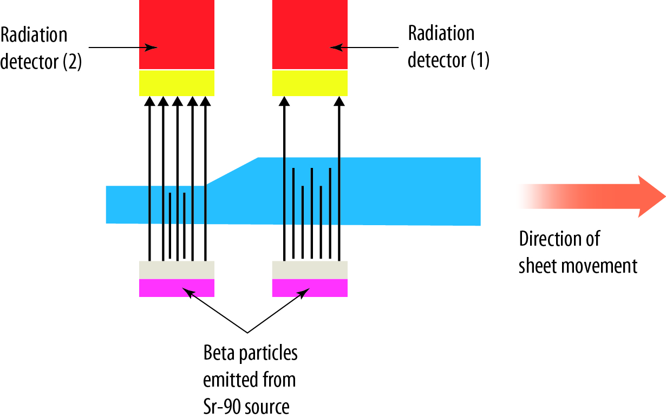

Compare the intensity of beta radiation detected by Detector (1) and Detector (2).
............................................................................................................................................................

- Radiometric dating of fossils is limited to ten half-lives.
- If the half-life of C-14 is 5730 years, what is the oldest fossil whose age can be determined by this technology?
.......................................................................................................................................................
- Why can't the age of 100 000 year old fossils be determined by C-14 dating?
.......................................................................................................................................................

- The products of radioactive decay are often radioactive themselves. This radioactive waste needs to be safely stored for long periods of time (often hundreds or thousands of years). Identify methods and sites that can be used to store radioactive waste.
..........................................................................................................................................................................................................................................................................................................................

Answers
- Half -life = 15 minutes

- Elements with even atomic numbers have more stable isotopes than elements with odd atomic numbers.

- 10 n
- 80–84 n
- The n:p ratio has to increase from 1:1.
- Unstable, as the n:p ratio is too low for a stable isotope

- 6.25% of the C-14 remaining means it has decayed for 4 half-lives. Thus the age of the fossil is
4 × 5730 = 22920 years.

- Total protons = 2 + 7 = 9; total neutrons = 2 + 7 = 9
- Protons = 8; neutrons = 9
- A proton

- Fission
- Krypton-92 (36 protons and 56 neutrons)

- I-131 has 8 more neutrons than I-123.
- I-123 has a much shorter half-life, so the isotope spends less time in the body and less damage can be caused by the radiation.
- As the gamma rays are much less energetic, they cause less damage to tissues than the more energetic betas.

- Detector (1) registers a lower intensity of the beta radiation than Detector (2) because the sheet is thicker under Detector (1) and more betas are absorbed by the foil.

- Age = 10 x 5730 = 57300 years
- There is so little C-14 remaining that the technology is not sensitive enough to measure it.

- Waste is often stored underground in steel containers in stable geological structures (e.g. deep salt mines) as it must not be allowed to contaminate workplaces or the natural environment. ANSTO at Lucas Heights in Sydney has developed a waste storage material called Synroc, which immobilises the radioactive waste in a glassy ceramic so that it can be stored safely underground without the danger of leaching by groundwater.

